Critical Path for Rare Neurodegenerative Diseases
Critical Path Institute
1840 E River Road, Suite 100
Tucson, AZ 85718
www.c-path.org
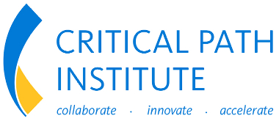

December 20, 2025

REQUEST FOR PROPOSAL

Critical Path Institute (C-Path) is seeking proposals from vendors to conduct qualitative research with people living with Amyotrophic Lateral Sclerosis (ALS) to support the measurement of meaningful outcomes and the construction of patient-centric endpoints through clinical outcome assessments (COAs), including those that use digital health technology (DHT). This research represents the next phase of following the United States (US) Food and Drug Administration’s (FDA’s) roadmap to patient-focused outcome measurement in clinical trials and will the generation of a portion of the evidence needed to support a fit-for-purpose COA for use in ALS clinical trials (FDA 2025).

The project will be coordinated by the Critical Path for Rare Neurodegenerative Diseases (CP-RND). Information contained in your proposal will be evaluated by employees of C-Path and will be considered confidential.

The proposal submission deadline is close of business on January 26, 2026. Your proposal (electronic document) should be submitted to:

Collin Hovinga, PharmD, MS, FCCP
Vice President, Rare, Orphan and Pediatric Disesase Program
chovinga@c-path.org

Cheryl Coon, PhD
Vice President, Clinical Outcome Assessment Program
ccoon@c-path.org

I. RFP Provisions

The proposal is a firm offer that will be considered valid for 180 calendar days from the due date. Please provide the contact information of the person responsible for submitting the proposal. C-Path shall not be responsible for any errors or omissions on the part of the Bidder in preparing this proposal. Bidder shall bear all costs associated with preparing this proposal.

Please prepare your proposed strategy to address the objectives and scope as stated in this RFP. You must demonstrate a knowledge base consistent with the objectives and requirements of this RFP. All of the required elements (i.e., methods, deliverables, milestones, experience, timelines, and costs) should be clearly explained in 30 pages or less. The project will be awarded based on organizational qualifications and experience in ALS, proposal content, schedule, and cost.

II. Introduction

Background

The Accelerating Access to Critical Therapies for ALS Act was signed into law in December 2021. Under Section 3 of the Act, National Institutes of Health (NIH) and FDA jointly selected the Critical Path Institute to be the conveyor of a public-private partnership. CP-RND is a public-private partnership for neurodegenerative diseases between the NIH, the FDA, and C-Path that brings together clinical experts, private entities, patient communities, and advocacy organizations to accelerate and advance our understanding of disease pathology, treatment options, diagnostics, and drug development. As part of CP-RND’s effort to identify and articulate unmet needs and key questions in medical product development that, if addressed, can tangibly accelerate drug development in rare neurodegenerative diseases, endpoints, and outcome measures appropriate for use in constructing patient-centric clinical trials for ALS are being pursued.

COAs have been developed for ALS, such as the ALS Functional Rating Scale-Revised (ALSFRS-R), a commonly-used clinician-reported measure of function including those functions of daily activities (Cedarbaum 1999). The FDA is open to other endpoints, COAs and COA types, including measures that leverage DHT, and the involvement of patients in documenting that a COA captures their own experiences is encouraged (FDA 2019). It is important that COAs meet both patient and regulatory expectations for them to be used in supporting clinically meaningful clinical trial endpoints.

Previously, C-Path led literature review work to understand what concepts of interest has been be assessed in clinical research, to identify COAs that may be appropriate for measuring these concepts of interest, to assess evidentiary gaps for existing COAs based on the literature, and to determine the landscape of DHTs being pursued in ALS (https://c-path.org/clinical-outcome-assessments-second-public-discussion/) . While the literature was robust for documenting a key set of concepts of interest (Table 1), the COA gap analysis and DHT landscaping work determined that qualitative evidence is lacking for the content validity and appropriateness of the existing ALS COAs and for the linking of DHT metrics to meaningful aspects of health. Thus, the next step in the work to support patient-centric endpoint measures in ALS is to conduct hybrid interviews, e.g concept elicitation and cognitive debriefing, to (1) identify any concepts missing from the literature review, (2) confirm the importance of the concepts of interest ideniftied in the literature to people with living experience (PWLE) and (3) confirm the ability of selected COAs, including those derived from DHTs, to measure those concepts.

Table 1. Concepts of Interest identified to Prioritize for Clinical Trial Study Endpoints

Activties of daily living | Behavioral | Bulbar | Cognitive | Digestive | Fatigue | Mental Health
Mobility | Motor | Nutrition | Pain | Physical Symptoms | Respiratory Symptoms | Sleep

The top 3 candidate domains identified in the literature are (1) bulbar, (2) motor, and (3) respiratory. While the list of concepts of interest to PWLE is broader than this list, these 3 concepts are those that were frequently mentioned in the literature, are measured by COAs with the best development evidence, and are likely to be relevant for primary or secondary endpoints. Additionally the CP-RND literature review identified COAs that were used more commonly in studies but require additional evidence generation to support endpoint development are (a) the ALS Impairment Multidomain Scale (AIMS; bulbar, motor, respiratory), (b) the Center for Neurological Study Bulbar Function Scale (CNS-BFS; bulbar), and (c) the ALS Assessment Questionnaire (ALSAQ-40, bulbar, motor), this is not an exhausitive list. Hybrid interviews will allow for concepts of interest to be spontaneously reported to identify any new concepts not previously documented in the literature and to confirm the literature review findings, followed by a guided process of evaluating if the items within each of these COAs measures relevant concepts, are written in a comprehensible way, and if any relevant items are missing from the COAs. Interviews should also help determine what concepts might be optimally measured using a DHT. The need to debrief each item may also be impacted and adjusted based on information from cognitive interviews. Persons living with ALS and caregivers should be included in this project.

The information gained from these qualitative interviews would be used to determine if the COAs are comprehensive and ready for psychometric evaluation, if revision is needed for the item wording/recall, response scales, or generation of new items, or if resources would be better spent developing a new COA that meets regulatory expectations. Thus, this qualitative research serves as an important step in following the COA roadmap from FDA’s third guidance in the Patient-Focused Drug Development series, which has been reproduced in Figure 1 below (FDA 2025). It will determine which of the three arrows should be followed within the step of “Selecting/Developing the Outcome Measure,” and it will likely serve as evidence that would be documented within the step of supporting a “Fit-for-Purpose COA” (i.e., populating the evidence-based rationale components). Additionally, this qualitative research will be leveraged to inform the extraction of features and construction of algorithms necessary for deriving meaningful metrics from DHT-based assessments, thus serving as necessary evidence for justifying that scores from the DHT-based measure correspond to the meaningful aspect of health related to the COI (FDA 2025; evidence-based rationale Component H).

Figure 1. Roadmap to Patient-Focused Outcome Measurement in Clinical Trials
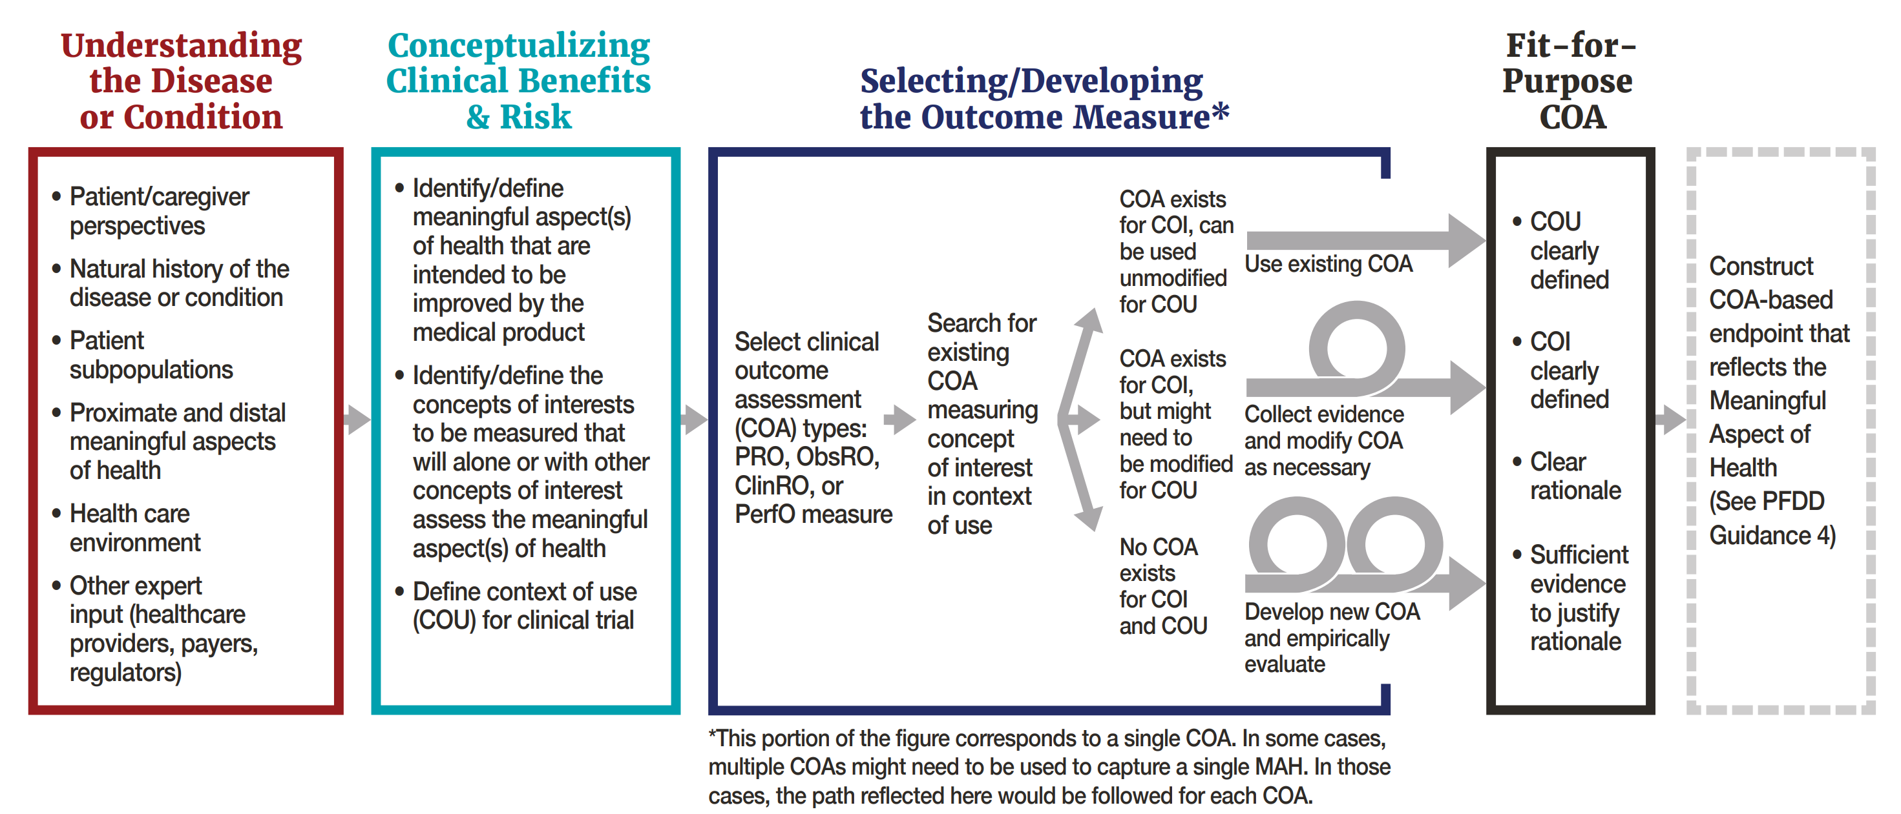
Figure reproduced from FDA 2025.

III. Methods

The project scope should cover the following aspects:

- Develop protocol, interview guide(s), and related study documents
- Develop a detailed qualitative analysis plan (QAP), which will describe how data from the qualitative research study will be analyzed and summarized
- Obtain feedback from C-Path and its collaborators on the protocol, interview guide(s), and QAP. This should include inclusion of persons with living experience and caregivers.
- Determine process for recruitment, screening, and enrollment of study participants,
- Obtain institutional review board (IRB) approval for the study protocol.
- Recruit participants for study. Study sample will need to include a sufficient number of participants, including potential subgroups (e.g., bulbar vs motor onset and/or familiar vs sporadic)if determined to be necessary, with a minimum of 30 participants. Recruitment for the study must meet standard diversity requirements (i.e., geographic, age, sex, race, ethnicity, education) and will need to include caregivers.
- Conduct individual interviews. The length of interviews should be appropriate for the patient population, and multiple interviews with the same participant may be considered if the desired scope of the interviews cannot be completed within a single session. Alternatively, a larger sample could be recruited, with each participant completing a pre-determined portion of the interview scope.
- Execute QAP based on interview transcripts
- Develop report of qualitative study findings, including recommendations regarding the use of existing COAs, the need for further COA development or modification, and an evidence-based proposal for feature extraction and algorithm development for DHT-based COA metrics.
- Outline a plan for manuscript(s) to disseminate the work in conjunction with C-Path.

Deliverables

- Study documents including qualitative study protocol, interview guide, and QAP; plan for three iterations of each
- Documentation of IRB approval of study documents
- Coding dictionary
- Qualitative study report; three iterations expected
- Interview recordings to be held by contractor in de-identified format and made available to C-Path upon request; de-identified interview transcripts should be provided to C-Path in a format to be defined.
- Documents suitable for manuscript development as outlined in the proposed plan.

IV. Review Meetings and Overall Project Management

It is anticipated that the selected vendor will participate in regularly scheduled teleconferences (e.g., 2 per month) to provide updates on the project, including discussion of the development of study materials, progress on recruitment, and presentation of study findings.

V. Previous Experience

Please define your organization’s capabilities and describe previous experience with COA development and/or testing. Describe any unique insights that you would bring to this project, including previous work with the ALS community and previous work on DHT-based endpoint measures.

VI. Key Personnel

Brief descriptions (300 words or less) of the roles, responsibilities, and background of key personnel and who will be involved in the project should be provided as an Appendix.

VI. Timeline

A detailed timeline including anticipated completion dates for the deliverables should be provided, with project launch by early February 2026. Projected timelines for completion of the project will be an element of the proposal evaluation criteria.

VII. Costs

Costs are to be broken out and identified per task and deliverable. Third party expenses (e.g., honoraria, must be identified and totaled separately from your direct service costs in relation to all tasks of this project. Please provide your proposed budget using the templates for direct, pass-through, and optional task costs provided below. Please provide your proposed budget in US dollars and proposed payment terms based on project milestones in the budget template provided.

REFERENCES

ALS Association. The ALS Voice of the Patient Report. October 2019; Available at: https://www.als.org/sites/default/files/2020-06/VOP-ALS_FINAL_For-Posting-10-23-19.pdf

Cedarbaum JM, Stambler N, Malta E, et al. The ALSFRS-R: a revised ALS functional rating scale that incorporates assessments of respiratory function. J Neurol Sci. 1999;169(1-2):13-21

US Food and Drug Administration. Guidance for Industry— Amyotrophic Lateral Sclerosis: Developing Drugs for Treatment (Final). September 2019; Available at: https://www.fda.gov/media/130964/download

US Food and Drug Administration. Guidance for Industry—Patient-Focused Drug Development: Selecting, Developing, or Modifying Fit-for-Purpose Clinical Outcome Assessments. October 2025; Available at: https://www.fda.gov/media/139088/download

BUDGET TEMPLATE

Note: Below entries are required at a minimum; additional details will be appreciated.
Direct Costs

Task Name | Time to Completion from Kickoff (in Weeks) | Total Hours for All Staff | Blended Hourly Rate | Total
Project Kickoff and Project Management | N/A |  |  | $
Prepare for Qualitative Study |  |  |  | $
Conduct Qualitative Study |  |  |  | $
Perform Analysis and Document Results of Qualitative Study |  |  |  | $
Additional Tasks (if any)
Total Direct Costs |  |  |  | $

Pass-through expenses are included as estimated costs. Actual pass-through expenses are to be billed monthly as incurred.

Exepense Description | Units | Cost per Unit | Total
IRB fees |  |  | $
Participant fees (patients and caregivers) |  |  | $
Streaming audio/video |  |  | $
Transcription |  |  | $
Other (please provide description) |  |  | $
Total Pass-Through Costs |  |  | $

Total Budget (Direct and Pass-Through)  (Excluding Optional Expenses) | $

Optional Tasks

Task Name | Time to Completion from Kickoff (in Weeks) | Total Hours for All Staff | Blended Hourly Rate | Total
Optional Task #1 (please specify) | N/A |  |  | $
Optional Task #2 (please specify) | N/A |  |  | $
Optional Task #3 (please specify) | N/A |  |  | $

PAYMENT TERMS:
Proposed payment terms, tied to specific deliverables or defined milestones for direct costs, are to be provided in the proposal submitted. Pass-through expenses will be invoiced as costs are incurred and should not be included in milestone payments.

